Week 3 Task: Advanced Data Analysis and Visualization in Logistics

Table of Contents:
1. Introduction
2. Purpose and Objectives
3. Logistics Problem Statement
4. Dataset Description
5. Data Simulation Method
6. Data Preparation and Quality Checks
7. Exploratory Data Analysis
8. Descriptive Statistics
9. Analysis by Transport Mode
10. Analysis by Region
11. Analysis by Shipment Priority
12. Data Visualizations
13. Correlation Analysis
14. Key Analytical Insights
15. Operational Bottlenecks
16. Recommendations
17. Limitations of the Analysis
18. Python Code
19. Conclusion

1. Introduction:
Logistics is an area where a large amount of data is generated every day. Information about shipments, delivery time, distance, transportation cost, delays and customer feedback can be used to understand how well a logistics operation is performing. Instead of looking at individual shipments one by one, data analysis makes it possible to identify patterns across many shipments.
For this task, I created a hypothetical logistics dataset and analysed it using Python. The dataset represents shipments moving through different regions using road, rail and air transport. I focused on a few common logistics performance questions: How long do deliveries take? Which transport mode is faster or more expensive? Are longer distances connected with higher costs? Are some regions experiencing more delays? How are the numerical variables related to each other?
I used Pandas to organize and analyse the data, NumPy to generate the simulated values, and Matplotlib to create visualizations. The analysis is designed as a learning exercise and does not represent the actual performance of a particular logistics company.

2. Purpose and Objectives:
The main purpose of this task is to understand how exploratory data analysis and visualization can support logistics decision-making. The specific objectives are:
- Create a realistic-looking hypothetical logistics dataset.
- Understand the structure and quality of the dataset before analysis.
- Calculate basic statistical measures such as mean, median, minimum, maximum and standard deviation.
- Study the distribution of delivery times and transportation costs.
- Compare the performance of road, rail and air transportation.
- Compare delivery performance across different regions.
- Study the difference between Standard and Express shipments.
- Investigate the relationship between distance, shipment volume, delivery time and cost.
- Use charts to make important patterns easier to understand.
- Identify possible operational bottlenecks and suggest practical improvements.

3. Logistics Problem Statement:
A logistics company needs to balance three important factors: delivery speed, transportation cost and service reliability. A very fast delivery option may have a higher cost, while a lower-cost option may take more time. Long-distance shipments may also have a higher probability of delay. Therefore, management needs data to decide where improvements are required.
In this project, the simulated dataset is used to answer the following questions:
- What is the typical delivery time for a shipment?
- How much does transportation cost on average?
- Which transport mode provides faster deliveries?
- Which transport mode has the highest average transportation cost?
- Which regions have higher delay rates?
- Does increasing distance generally increase transportation cost?
- Does shipment volume affect transportation cost?
- How does delivery performance relate to customer ratings?
- What areas should a logistics manager investigate first?

4. Dataset Description:
The dataset contains 250 shipment records. Each row represents one shipment and contains information about the shipment itself, the transportation method, distance, delivery performance, cost and customer rating.
Variable | Data Type | Purpose
Shipment_ID | Categorical | Unique shipment identifier
Region | Categorical | Geographical operating region
Transport_Mode | Categorical | Mode used for transportation
Priority | Categorical | Standard or Express service
Shipment_Volume_kg | Numeric | Weight/volume of shipment
Distance_km | Numeric | Approximate delivery distance
Delivery_Time_days | Numeric | Number of days taken for delivery
Transport_Cost_INR | Numeric | Estimated transportation cost
Delay_Status | Categorical | Whether shipment was delayed
Customer_Rating | Numeric | Customer satisfaction score
The categorical variables allow comparisons between groups, while the numerical variables allow calculations such as averages, ranges and correlations. Keeping both types of variables is important because logistics performance depends on both measurable quantities and categories such as region and transportation mode.

5. Data Simulation Method:
Because a real logistics dataset was not supplied, I generated the data using Python. A fixed random seed was used so that the same dataset can be recreated. Shipment volumes were generated between 20 kg and 500 kg, while distances were generated between 50 km and 2,000 km. Road was given the largest share of shipments, followed by rail and air.
Delivery time was simulated using distance as a base factor and then adjusted according to transport mode and shipment priority. Transportation cost was generated using distance, shipment volume and a different rate for each transport mode. Delay probability was also varied according to distance, mode and large shipment volume. This gives the dataset relationships that are similar to the types of relationships that can appear in a real logistics environment.
The simulated nature of the data is important to remember. The purpose is to demonstrate the analysis process rather than make claims about a real company.

6. Data Preparation and Quality Checks:
Before calculating insights, I checked the basic quality of the dataset. The first few rows were inspected using the head() function. The info() function was used to check the data types and number of records. I also checked for missing values using isnull().sum().
Column | Missing Values
Shipment_ID | 0
Region | 0
Transport_Mode | 0
Priority | 0
Shipment_Volume_kg | 0
Distance_km | 0
Delivery_Time_days | 0
Transport_Cost_INR | 0
Delay_Status | 0
Customer_Rating | 0
There are no missing values in the simulated dataset. This means no imputation or row removal was required. In a real logistics dataset, missing delivery dates, missing costs or missing shipment weights would need to be handled carefully because they could affect the results.
I also checked whether the numerical columns contained reasonable values. Delivery time is positive, shipment volume is within the selected simulation range, distance is positive, and customer ratings remain within the 1 to 5 range.

7. Exploratory Data Analysis:
Exploratory Data Analysis, or EDA, is the stage where the data is examined before making final conclusions. I used EDA to understand the centre, spread and overall behaviour of the main variables. I also compared groups using transport mode, region and priority.
- The average delivery time is 3.11 days.
- The median delivery time is 3.00 days.
- The standard deviation of delivery time is 1.37 days.
- The average transportation cost is INR 16,277.97.
- The median transportation cost is INR 9,537.58.
- The average shipment volume is 249.37 kg.
- The average shipment distance is 1038.08 km.
- The average customer rating is 4.16 out of 5.
- The overall simulated delay rate is 17.60%.

8. Descriptive Statistics:
Descriptive statistics give a quick summary of the numerical variables. The mean represents the average, the median represents the middle value, and the standard deviation shows how much the observations vary around the average.
Variable | Mean | Median | Std. Dev. | Minimum | Maximum
Shipment_Volume_kg | 249.37 | 248.00 | 142.58 | 20.00 | 500.00
Distance_km | 1038.08 | 1049.00 | 557.65 | 60.00 | 1984.00
Delivery_Time_days | 3.11 | 3.00 | 1.37 | 1.00 | 6.60
Transport_Cost_INR | 16277.97 | 9537.58 | 18827.03 | 83.65 | 104748.66
Customer_Rating | 4.16 | 4.20 | 0.34 | 3.10 | 5.00
One useful comparison is between the mean and median. If the mean is noticeably higher than the median, it can indicate that some unusually high values are pulling the average upward. This is particularly useful for logistics cost and delivery-time data because a small number of unusually expensive or late shipments can influence the overall average.

9. Analysis by Transport Mode:
Transportation mode is one of the most important categorical variables in the dataset. Road, rail and air can have different speed and cost characteristics. I grouped the data by transport mode to compare shipment count, delivery time, cost, delay rate and customer rating.
Mode | Shipments | Avg Delivery Days | Median Delivery Days | Avg Cost INR | Avg Volume kg | Delay Rate % | Avg Rating
Air | 39 | 2.31 | 2.40 | 37,015.30 | 262.59 | 17.95 | 4.26
Rail | 63 | 3.76 | 3.90 | 9,359.39 | 232.46 | 11.11 | 4.11
Road | 148 | 3.04 | 2.90 | 13,758.47 | 253.08 | 20.27 | 4.15
In this simulation, Air has the lowest average delivery time, while Rail has the highest average delivery time. Air has the highest average transportation cost and Rail has the lowest. These results show why a logistics manager should not judge a transport mode using only one metric. The best option depends on whether speed, cost or service reliability is more important for a particular shipment.

10. Analysis by Region:
Regional analysis can help identify geographical areas where the logistics network may be performing differently. I calculated the number of shipments, average delivery time, average cost, delay rate and average customer rating for each region.
Region | Shipments | Avg Delivery Days | Avg Cost INR | Delay Rate % | Avg Rating
East | 67 | 3.18 | 15,308.54 | 16.42 | 4.11
North | 59 | 3.04 | 15,671.05 | 20.34 | 4.21
South | 56 | 3.25 | 15,347.08 | 19.64 | 4.13
West | 68 | 2.98 | 18,526.33 | 14.71 | 4.17
The highest simulated delay rate occurs in the North region, while the lowest occurs in the West region. This difference can be used as a starting point for further investigation. In real operations, the next step would be to break the regional results down by individual carrier, route, warehouse, day of week and shipment type.

11. Analysis by Shipment Priority:
Priority was included to represent the difference between normal and urgent shipments. Express shipments are expected to receive faster service, although the exact cost difference depends on the transportation arrangement.
Priority | Shipments | Avg Delivery Days | Avg Cost INR | Delay Rate % | Avg Rating
Express | 77 | 2.49 | 14,463.42 | 10.39 | 4.30
Standard | 173 | 3.38 | 17,085.60 | 20.81 | 4.09
Comparing priority groups helps determine whether the faster service is actually reflected in delivery time. It also gives a basic view of the trade-off between service level and cost. For a real company, this analysis could be expanded to compare promised delivery time with actual delivery time and calculate the percentage of shipments meeting the service-level agreement.

12. Data Visualizations:
Visualization is useful because a table can contain a lot of information but may not immediately show a pattern. I selected different charts based on the question being asked. Histograms were used for distributions, bar charts for category comparisons, scatter plots for relationships, and a correlation matrix for numerical relationships.

12.1 Delivery Time Distribution:
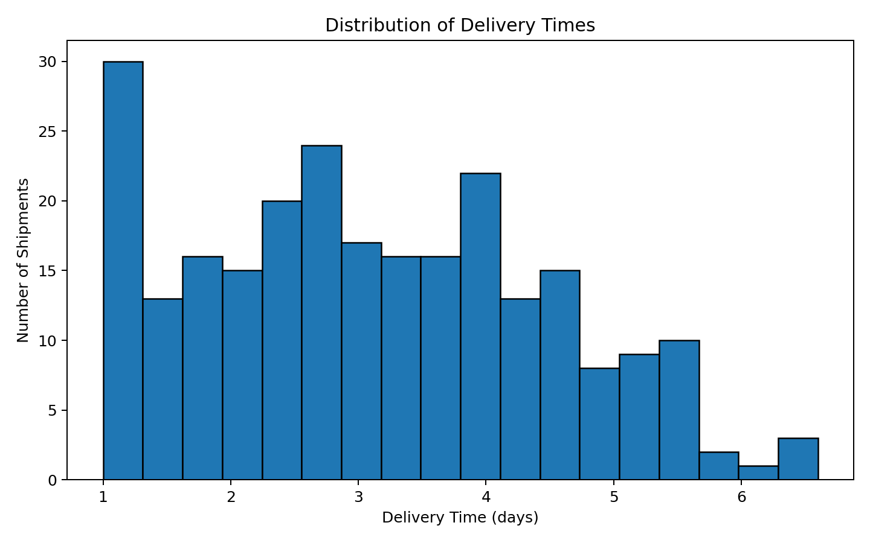
What the chart shows: A histogram was selected because the main question is how delivery time is distributed across the shipments. The chart makes it easier to see the most common delivery-time range and whether there are relatively few shipments with unusually long delivery times. In a logistics setting, these unusual long deliveries are worth investigating because they may represent bottlenecks.
How it can be used: A manager can use this chart to set a realistic standard delivery range and identify shipments that fall far outside the normal range.

12.2 Average Delivery Time by Transport Mode:
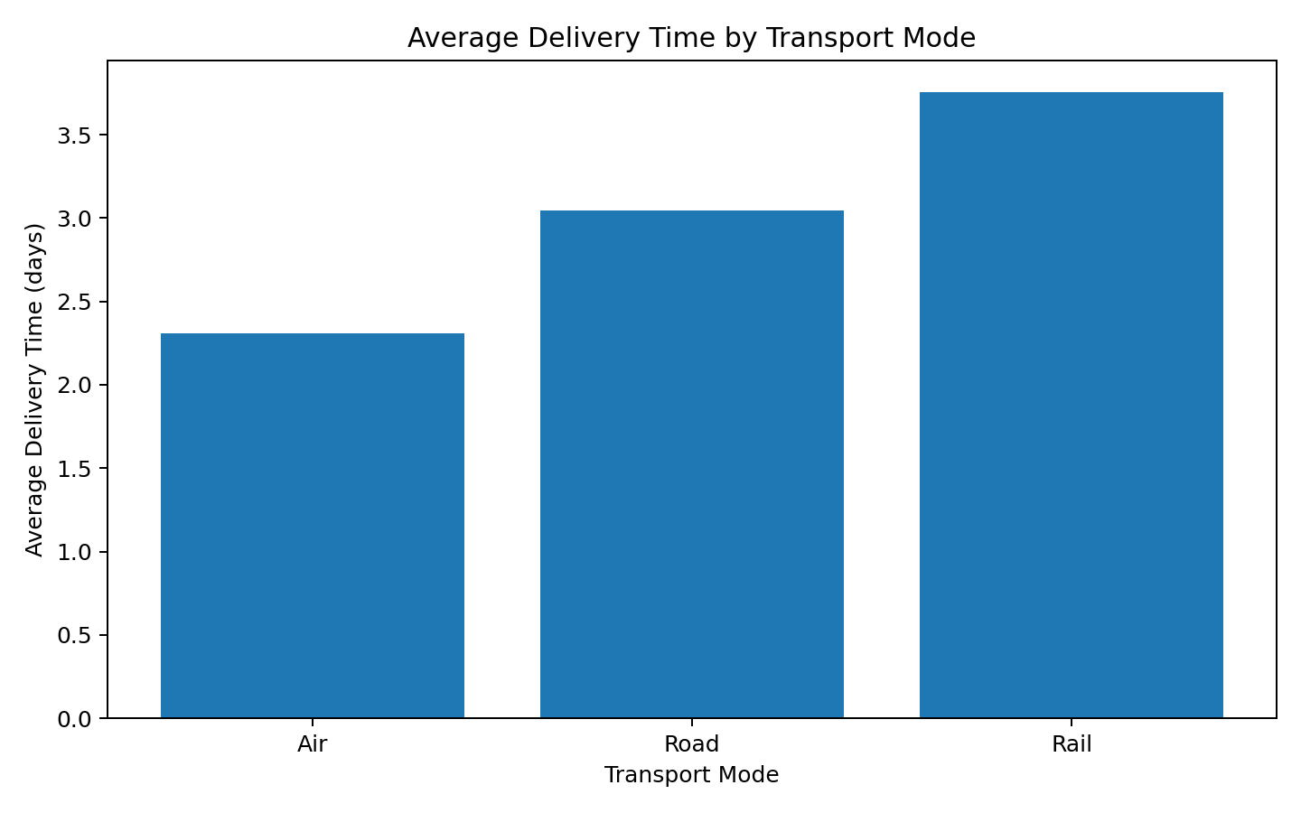
What the chart shows: The bar chart compares the average delivery time of Road, Rail and Air. Bar charts work well for categorical comparisons because the height of each bar can be compared directly.
How it can be used: This visualization helps with transport planning. If a shipment is time-sensitive, the company can consider the faster mode. If the shipment is less urgent, a lower-cost mode may be preferred.

12.3 Transportation Cost vs Distance:
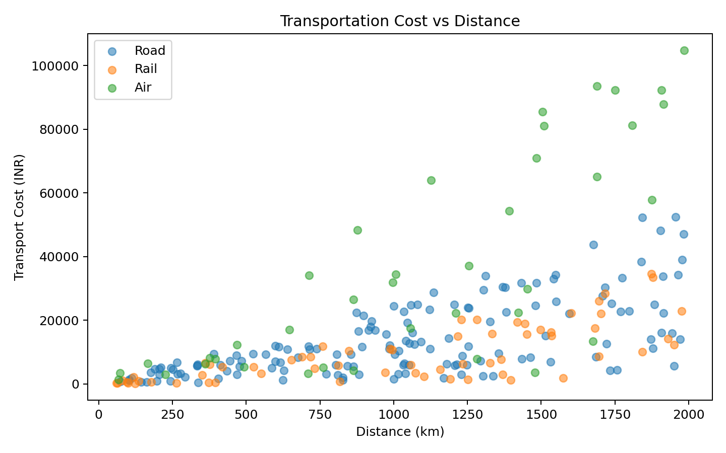
What the chart shows: A scatter plot was used because both distance and cost are continuous numerical variables. Each point represents a shipment, and the different groups represent transportation modes.
How it can be used: The graph helps show that longer distances generally require more transportation spending. The separation between modes also suggests that the selected mode changes the cost structure. This is useful when preparing quotations or planning routes.

12.4 Delay Rate by Region:
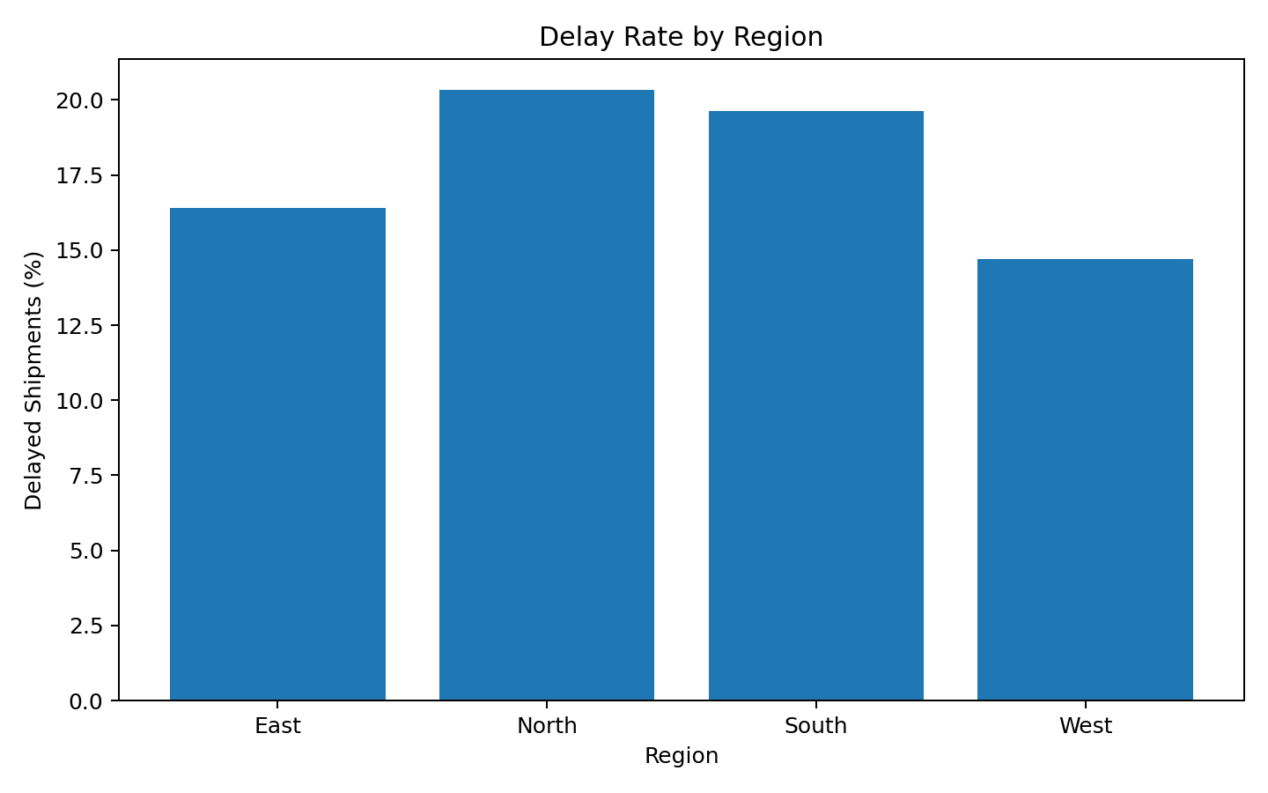
What the chart shows: The regional delay chart compares the percentage of shipments marked as delayed in each region. Percentage rather than only the number of delays is more useful because the regions can have different shipment counts.
How it can be used: The chart can help management prioritize investigations. A region with a high percentage of delays may need route, carrier, warehouse or scheduling improvements.

12.5 Correlation Matrix:
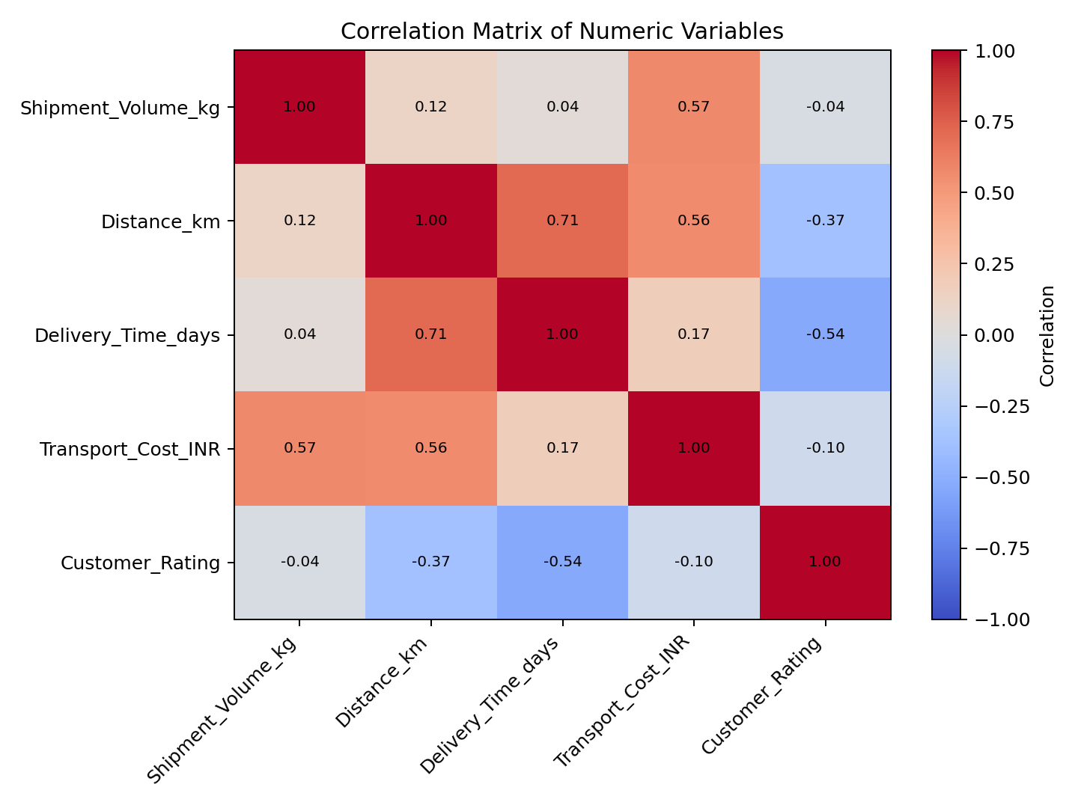
What the chart shows: The correlation matrix summarizes relationships between the numerical variables. Values closer to +1 indicate a strong positive relationship, values closer to -1 indicate a strong negative relationship, and values around zero indicate a weaker linear relationship.
How it can be used: This is useful for identifying variables that deserve further analysis. Correlation does not prove that one variable causes another, so the results should be treated as a starting point rather than a final explanation.

13. Correlation Analysis:
Correlation was calculated using the numerical variables. The purpose was to check whether variables tend to move together. The values do not prove cause and effect, but they can show where a stronger relationship exists.
Variable | Shipment_Volume_kg | Distance_km | Delivery_Time_days | Transport_Cost_INR | Customer_Rating
Shipment_Volume_kg | 1.00 | 0.12 | 0.04 | 0.57 | -0.04
Distance_km | 0.12 | 1.00 | 0.71 | 0.56 | -0.37
Delivery_Time_days | 0.04 | 0.71 | 1.00 | 0.17 | -0.54
Transport_Cost_INR | 0.57 | 0.56 | 0.17 | 1.00 | -0.10
Customer_Rating | -0.04 | -0.37 | -0.54 | -0.10 | 1.00
The transportation cost variable is expected to have a strong relationship with distance and shipment volume because the simulated cost formula was based partly on these variables. Delivery time is also influenced by distance in the simulation. Customer rating is generally affected by delivery experience, so longer delivery times and delays can be associated with lower ratings.
In real-world analysis, correlation should be combined with additional methods such as regression analysis, hypothesis testing or machine learning before making strong business decisions.

14. Key Analytical Insights:
- The typical shipment takes around 3.00 days based on the median delivery time.
- The overall average delivery time is 3.11 days, which gives a useful baseline for performance monitoring.
- The simulated delay rate is 17.60%, meaning that a noticeable portion of shipments experienced a delay.
- Average transportation cost is about INR 16,277.97, but cost varies because shipment distance, volume and transport mode differ.
- Air is the fastest mode on average in the simulated data, while Rail is the slowest.
- Air has the highest average transportation cost in the simulation, showing the cost of prioritizing speed.
- The North region has the highest simulated delay rate and could be selected for deeper investigation.
- Distance and shipment volume are important cost drivers in the simulated data.
- Delivery experience is connected with customer rating, so improving delivery performance can potentially improve customer satisfaction.

15. Potential Operational Bottlenecks:
A bottleneck is a part of the logistics process that limits overall performance. The analysis does not directly measure warehouse processing time, vehicle utilization or route congestion, but it gives clues about where problems may exist.
Long-distance shipments: Longer distances can increase both delivery time and cost. These shipments may need better route planning and scheduling.
Regional delays: The North region has the highest simulated delay rate. A real company should check whether this is related to specific routes, carriers or local conditions.
Transport-mode selection: Choosing a mode only because it is cheap can create service problems if the delivery deadline is strict. Mode selection should consider both time and cost.
Large shipments: High shipment volumes can increase transportation costs and may require better vehicle capacity planning.
Late deliveries and customer satisfaction: Repeated delays may reduce customer ratings. Tracking delayed shipments together with customer feedback can help identify service-quality issues.

16. Recommendations:
- Create a daily or weekly dashboard for delivery time, delay percentage, transportation cost and customer rating.
- Investigate shipments that take much longer than the normal delivery-time range.
- Compare carriers and routes within each region instead of comparing regions only at a high level.
- Use distance, shipment volume and transport mode when estimating transportation cost.
- Use faster transportation modes for genuinely urgent shipments and lower-cost modes for shipments where the deadline allows more time.
- Monitor regional delay rates regularly so that a temporary problem can be identified before it becomes a long-term issue.
- Track promised delivery date versus actual delivery date to calculate service-level performance.
- Combine operational data with fuel prices, traffic conditions, warehouse processing times and carrier information for a more complete analysis.
- Use historical data to forecast shipment volume and plan vehicle and warehouse capacity.
- Repeat the analysis every month or quarter so that management can compare performance over time.

17. Limitations of the Analysis:
There are several limitations because this project uses simulated data. The numbers are not from a real logistics company, so the findings should not be treated as actual business results.
- The dataset contains only 250 shipments.
- The values were generated using assumptions rather than real operational records.
- Important factors such as fuel prices, weather, traffic, warehouse processing time and carrier performance were not included.
- The dataset does not contain actual promised delivery dates or service-level agreements.
- The analysis mainly focuses on descriptive statistics and visual exploration rather than predictive modelling.
- Correlation does not prove causation.

19. Python Code Used:
The complete Python script is provided as a separate file. The following excerpts show the main steps used in the analysis.
Dataset inspection and quality check
# Check the dataset
print(data.head())
print(data.info())
print(data.describe())
# Check missing values
print(data.isnull().sum())
Basic statistical analysis
# Calculate basic statistics
print(data["Delivery_Time_days"].mean())
print(data["Delivery_Time_days"].median())
print(data["Transport_Cost_INR"].mean())
# Group by transport mode
mode_summary = data.groupby("Transport_Mode").agg(
Avg_Delivery_Days=("Delivery_Time_days", "mean"),
Avg_Cost=("Transport_Cost_INR", "mean")
)
print(mode_summary)
Distribution visualization
# Histogram
plt.hist(data["Delivery_Time_days"], bins=18, edgecolor="black")
plt.title("Distribution of Delivery Times")
plt.xlabel("Delivery Time (days)")
plt.ylabel("Number of Shipments")
plt.show()
Relationship visualization
# Scatter plot
for mode in ["Road", "Rail", "Air"]:
subset = data[data["Transport_Mode"] == mode]
plt.scatter(
subset["Distance_km"],
subset["Transport_Cost_INR"],
alpha=0.55,
label=mode
)
plt.xlabel("Distance (km)")
plt.ylabel("Transport Cost (INR)")
plt.title("Transportation Cost vs Distance")
plt.legend()
plt.show()
Correlation analysis
# Correlation matrix
corr = data.select_dtypes(include=np.number).corr()
print(corr)
plt.imshow(corr, cmap="coolwarm", aspect="auto", vmin=-1, vmax=1)
plt.colorbar(label="Correlation")
plt.show()

20. Conclusion:
This project helped me understand how data analysis can be applied to a logistics problem. I started by creating a hypothetical dataset and then checked its structure and quality before performing calculations. I used descriptive statistics to understand the centre and spread of the data and grouped the shipments by transport mode, region and priority to make comparisons.
The visualizations made the results easier to interpret. The histogram showed the distribution of delivery times, the bar charts helped compare groups, the scatter plot showed the relationship between distance and cost, and the correlation matrix provided a quick overview of numerical relationships. These techniques can help logistics managers identify areas that need attention.
The analysis suggests that delivery performance and transportation cost should be considered together. Longer distances and larger shipments can increase cost, while transport mode affects both delivery speed and cost. Regional delay analysis can also help management focus resources on areas where service performance is weaker.
Overall, the exercise showed me that visualization is not only about making charts. The main purpose is to turn raw data into information that can support a decision. With real logistics data, this approach could be extended with forecasting, predictive modelling, route analysis and interactive dashboards.

Appendix A: Sample Records:
Shipment_ID | Region | Transport_Mode | Priority | Shipment_Volume_kg | Distance_km | Delivery_Time_days | Transport_Cost_INR | Delay_Status | Customer_Rating
SHP1001 | East | Road | Standard | 490 | 1304 | 3.50 | 29487.08 | On Time | 3.90
SHP1002 | West | Rail | Express | 97 | 972 | 3.00 | 3615.49 | On Time | 4.20
SHP1003 | North | Air | Standard | 235 | 469 | 1.90 | 12274.79 | On Time | 4.30
SHP1004 | East | Road | Express | 405 | 206 | 1.00 | 4717.73 | On Time | 4.70
SHP1005 | East | Road | Standard | 384 | 599 | 2.60 | 11883.93 | On Time | 4.20
SHP1006 | West | Road | Standard | 173 | 1514 | 4.40 | 15150.37 | On Time | 3.80
SHP1007 | North | Road | Standard | 33 | 1170 | 4.90 | 1856.19 | On Time | 4.30
SHP1008 | North | Road | Standard | 206 | 1070 | 2.50 | 12475.86 | On Time | 4.20
SHP1009 | East | Road | Express | 331 | 1046 | 2.00 | 19198.90 | On Time | 4.60
SHP1010 | South | Air | Standard | 390 | 1484 | 2.50 | 70885.04 | On Time | 4.50

Appendix B: Project Files:
The project package includes the Word report, Python analysis script, simulated CSV dataset, and the visualization images used in the report.

